K-2 P.E. Choice Board
Pick one a day while working remotely.
Character Battle & ARMP Workout  Complete the following ARMP workouts  https://fultonk12-my.sharepoint.com/:b:/g/personal/poper1_fultonschools_org/EbIpSJCLGzhAnAT_Z1F2FrMBBlJ2yGQL3Ka2Tqa1NZu_3w?e=ovPxc0  https://fultonk12-my.sharepoint.com/:b:/g/personal/poper1_fultonschools_org/EeOeC3v2KuxOuGP66WcCbg4BHhyMqE-mkmWtvvmGn9-CFw?e=6dvR39  Complete the Character Battle Powperpoint  https://fultonk12-my.sharepoint.com/:p:/g/personal/poper1_fultonschools_org/EZbCsdICZQZLogdMc3-aMbMBP4ix9GaTUGNpEvR0iYP4lQ?e=BGl98s | GET OUT & PLAY  Go outside and complete the following list 2 times this week  - Do 6 cartwheels or rolls  - Take 15 GIANT steps  - Run to the nearest building or built object 3 times  - Hop on one foot 8 times-repeat with other foot  - Spin around with your arms stretched out 10 times  - Hop like a frog 7 times  - Take 15 GIANT steps backwards  - Walk like a crab to the nearest building or built object  - Walk like a bear for 30 seconds  - Dance around in a circle | Mission Possible - Task Sheet  Complete the following missions  - Do 8 sit-ups in each corner of the room.  - Skip one lap around the room.  -Do 12 jumping jacks  - Touch all 4 walls of the room.  - Hop on one foot from one end of the room to the other.  - Do 15 pretend basketball shots. Nothing but net!  - Crab walk and touch 3 chairs  - Jog on the spot and sing “Row, Row, Row Your Boat”.  - Pretend to jump rope for 1 minute.  - Do a wall push-up on each wall in the room.  - Do any dance move for 30 seconds.  - Complete 20 bunny hops.  - Grapevine or shuffle across the room and back 2 times.  Complete these tasks alone or do missions together as a team.  Complete the missions in any order.  When you are done with the missions, do a star jump and yell “Mission Accomplished!”
Adventure Time  Complete the Adventure Time Powerpoint  https://fultonk12-my.sharepoint.com/:p:/g/personal/poper1_fultonschools_org/ETwqgKM3yEpAhsefcN00GmMBuFydMlvHaWI59o_9rUazEA?e=diFwbe | Coin Fitness  Complete coin fitness  https://fultonk12-my.sharepoint.com/:b:/g/personal/poper1_fultonschools_org/ES_SGPMTNwVLg8eWOaDpu2wBjPLOf3xYw1B8A3CeWDQKKQ?e=d4AWV2  Complete color fitness  https://fultonk12-my.sharepoint.com/:b:/g/personal/poper1_fultonschools_org/EYuCs-Yc3hBIrwa0luv4IlgBpq45YeVD1Xa095YT6mGKkg?e=hkLOpn  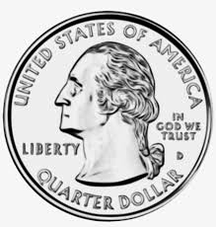 | STAR WARS WORKOUT  Perform 10 of each exercise  Squats  Toe Touches  Arm circles  Run in place  Walk backwards  Arms overhead  Reverse jumps  Stomp feet  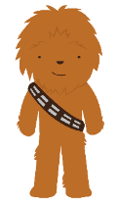
OUTDOOR  ADVENTURE HUNT  Go with a parent or guardian outside to find the following items.  - Something colorful  - A pinecone  - An acorn  - Something smooth  - Something rough  - Two kinds of leaves  - Two kind of sticks  - Something bumpy  - Something fuzzy  - A flower or petal  - Something you think is a treasure | WHAT’S YOUR NAME?  Spell your full name and complete the exercise listed for each letter.  A-10 jumping jacks  B-5 push-ups  C-5 burpees  D-20 high knees  E-5 crunches  F-10 mountain climbers  G-5 squats  H-10 lunges  I-10 side lunges  J-10 second wall sit  K-5 calf raises  L-30 second plank  M-10 jump squats  N-10 second jump rope  O-15 jumping jacks  P-15 side jumps  Q-10 arm circles  R-10 skates  S-20 second jog in place  T-10 butt kicks  U-5 burpees  V-10 tricep dips  W-20 jump in place  X-10 leg raises  Y-5 squats  Z-10 push-ups | Boot Camp  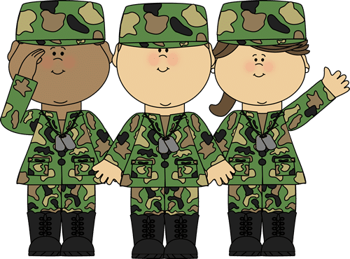  Complete the following boot camp workouts  https://fultonk12-my.sharepoint.com/:b:/g/personal/poper1_fultonschools_org/EbxIfRsAq-lDpHE8B4NTnrkByLqYSoRyWfW-99qBq_UW5w?e=4hrahr  https://fultonk12-my.sharepoint.com/:b:/g/personal/poper1_fultonschools_org/EQcPNDlLAkpKvOcOZJWPtp0BLw55lM0uW6AjEQQYBRAGKw?e=mFOeyz

