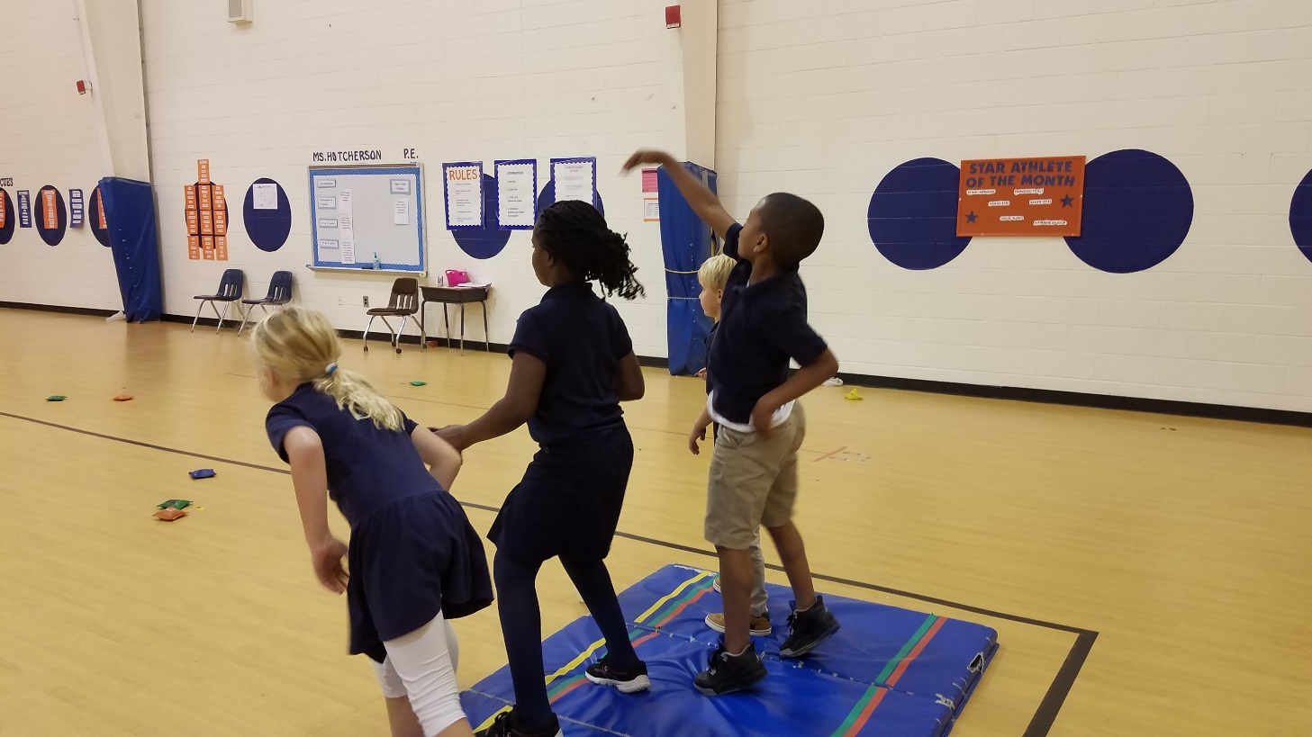 |  | Physical Education Newsletter  - Spalding Drive
 |  | Upcoming Events

Highlights
Welcome to the first Spalding Drive Physical Education Newsletter of the 2017-2018! During the month of August, all of the grade levels worked on their personal space and fitness. In the month of September, the kindergarten and first graders worked on locomotor skill. The second, third, fourth, and fifth graders worked on their chasing, fleeing and dodging unit. The third, fourth, and fifth grade also practiced the FitnessGram Pacer test in class. The Pacer test is an aerobic capacity test where students run laps back and forth in the gym at a timed speed. Every student worked extremely hard. Please look to the right to find the first place male and female finishers for third, fourth, and fifth grade. Congratulations to the winners! The students will retake this test again in January to determine if they have run enough laps to make it to the Pacer Hall of Fame and to see if they qualify for the field day race. The top 8 boys and girl finishers will qualify. This information will be in the February newsletter.

November 10
Children Helping Children’s

November 11
Girls on the Run 5k

December 14
4th-5th-Volleyball Tournament

3rd Grade 1st Place Pacer Scores:
Caterina Fedeli-43 laps
Daniel Evangelista-54 laps
4th Grade 1st Place Pacer Scores:
Julia Rutledge-59 laps
Nicolo Muraro-66 laps
5th Grade 1st Place Pacer Scores:
Kaylie Ha-42 laps
Jake Fogel-65 laps

Children Helping Children’s
On November 9th and 10th, every student will be participating in the fundraiser Children Helping Children’s! All students will go to their Physical Education class on November 9th or 10th and will participate in a variety of fun activities where they will practice exercises to become healthier and learn about a variety of diseases. Students can also make donations to the Children’s Healthcare of Atlanta and earn thank you prizes for their donations on those days. Children’s Healthcare of Atlanta treats over a million children a year with illness ranging from diabetes to cancer. Students will earn a glow in the dark duck for a $5 donation and a space and mustache duck for $15. The class that donates the most money will earn a popsicle party! Donation envelopes will be passed out on October 25th!
Second & Third Grade
The second and third classes have been having a blast working on their throwing and catching unit! Students are learning to perfect their underhand throw and are beginning to learn the overhand throw. Students have different the availability to throw and catch a variety of different balls such as dodgeballs, foam balls, tennis balls, and plastic balls. They also get the chance to throw towards a target and throw to a partner in a variety of games we play such as Battleship, The Lorax, Guard the Pin, Container Ball, and Powerball

Each month, one student from each grade level will be picked to be the star athlete of the month. The star athlete of the month is a student that exhibits responsible behavior in P.E. class. This student encourages other students, tries their hardest in every activity, does not complain, and has a positive attitude at all times. This student will be recognized in front of his or her class, will be given a certificate and a special prize, and will have their name on the star athlete of the month poster all month long. Below is a list of names of the Star Athletes of the Month.
K: Blake Turner
1ST: Hope Louine
2ND: Jackson Muraro
3RD: Sofia Berghoff
4TH: Wilma Tchouamou
5TH: Benny Griset

STAR ATHLETE OF THE MONTH/STAR CLASS

