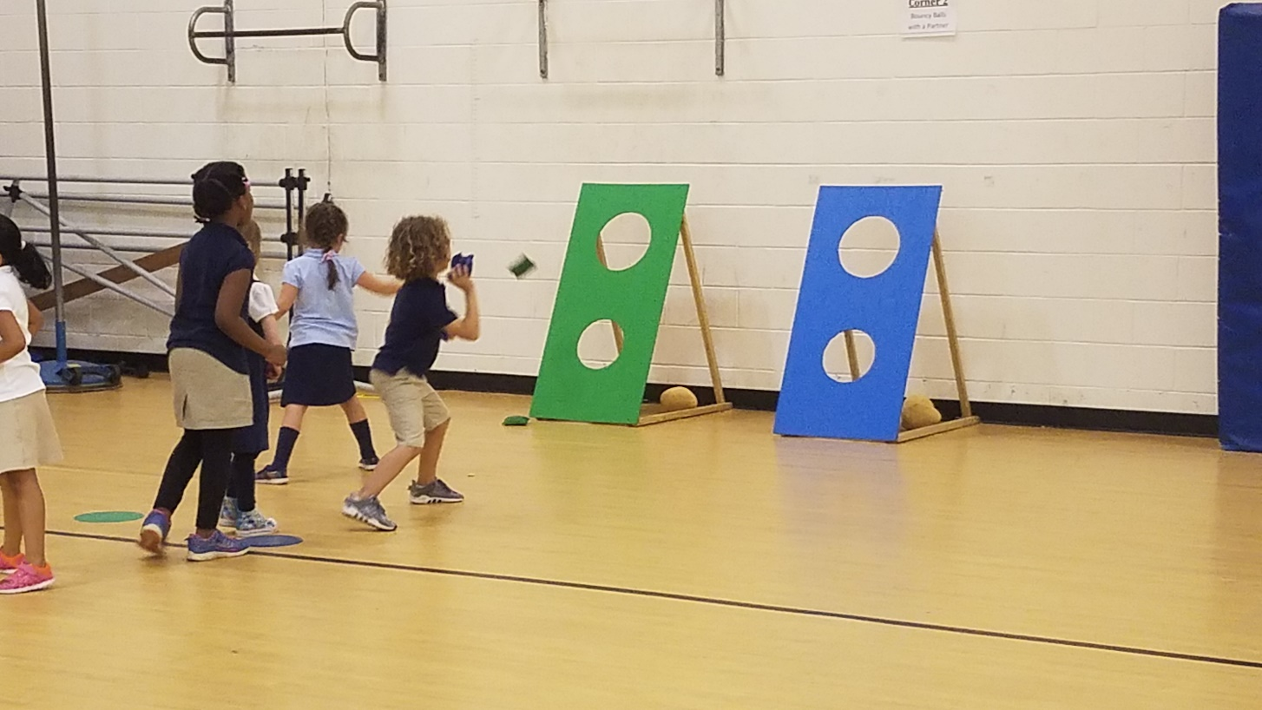 |  | Physical Education Newsletter  - Spalding Drive
Kindergarten practicing for field day! |  | Upcoming Events

Highlights
All grade levels are currently participating in the cooperation unit to get ready for Field Day. Field Day will be on Friday May 18th. The rain make up day will be on Monday May 21st. Field day will start at 8:15 and end at 11:15. The field day relay race for third through fifth grade will begin at 1:00 that afternoon.
To make this day successful, we need parent volunteers to manage the events. A team of volunteers to help set up in the morning at 7:15 am and one volunteer will be needed at each station. If you are available to assist, please go to the following website and sign up for any section listed you would like. Your help will ensure this day is a success. Detailed information about your station will be given to you when you arrive on field day at the check in desk in front of the gym.
Field Day Volunteer Sign up Link:
https://www.signupgenius.com/go/4090e48a5ad28a31-20182

May 18
Field Day

May 24
Last day of school

May 28
Memorial Day
Tiger Cross Country
The Tiger Cross Country Team’s 2 mile-fun run is over! Congratulations to all the boys for an amazing job! Thank you to everyone who came out to show their support. A special thanks to the coaches for all their help-Ms. Sprinkle, Mrs. Kutner, Mrs. Griffith, Mrs. Gewertz, and Mrs. Jsames.

Fourth & Fifth Grade
All fourth and fifth graders are also working on their cooperation unit. They have spent the last several weeks working on their running skills and have played fun lead up games such as Gladiator to get ready to play Capture the Flag. Students will be divided up into 2 separate teams and we will go outside to see who wins in Capture the Flag.
Kindergarten & First Grade
The kindergarten and first grade grade classes are currently working on their Cooperation unit! Ms. Sargent, Mrs. Shivers, and Mrs. Satterfield’s classes have been doing a wonderful job! They are playing fun games like Zoo Animals, Clean the Yard, and Team Memory. They are also going to spend the last week of school playing games such as jaws, mushroom, cat attack, and popcorn with the giant parachute!

Each month, one student from each grade level will be picked to be the star athlete of the month. The star athlete of the month is a student that exhibits responsible behavior in P.E. class. This student encourages other students, tries their hardest in every activity, does not complain, and has a positive attitude at all times. This student will be recognized in front of his or her class, will be given a certificate and a special prize, and will have their name on the star athlete of the month poster all month long. Below is a list of names of the Star Athletes of the Month.
K: Grant Painter
1st: Noah Santamaria
2nd: Vedika Soni
3rd: Kyle Grayson
4th: Kate Lott
5th: Jace Jackson

STAR ATHLETE OF THE MONTH

